CUES Executive Compensation Survey
Frequently Asked Questions
Participation

Contact CUES Survey Support at 866.508.0744 or surveysupport@cues.org for additional help.

When is the participation period?
Survey participation opens Jan 1 and closes March 31.

How long does the survey take?
While participation time varies depending on how many positions you are submitting, we estimate each position should take no more than 15 minutes if you have your salary and compensation information on hand.

What will I need to have on hand?
For each position, have the following ready:
- Base salary
- Bonus, incentives, and other taxable compensation information
- Professional development costs for the past year and projected for now and the next year
- Car allowance
- Benefits

How do I access the survey to participate?
Go to the Executive Compensation Survey page at cues.org/ecs, or navigate to the page through the Products and Services page on cues.org.

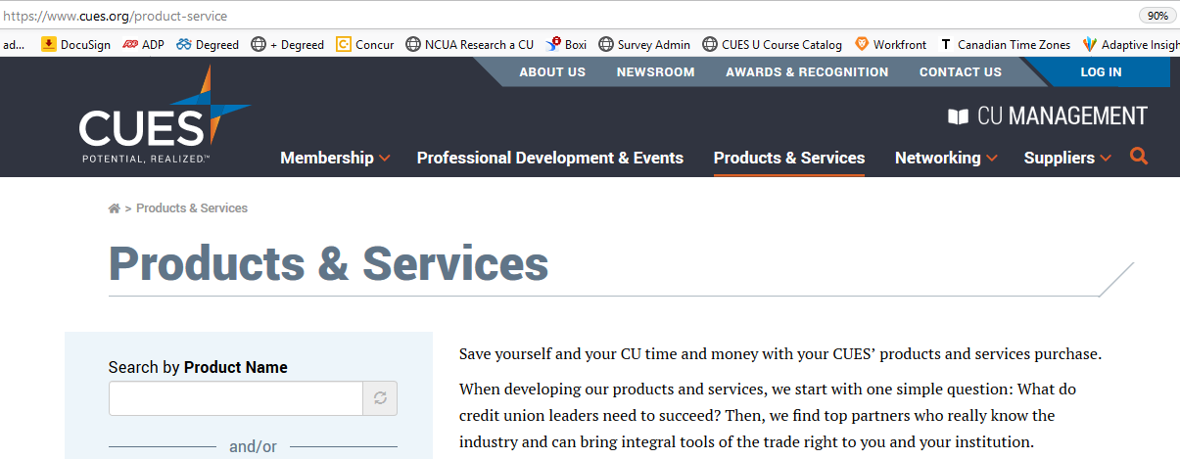
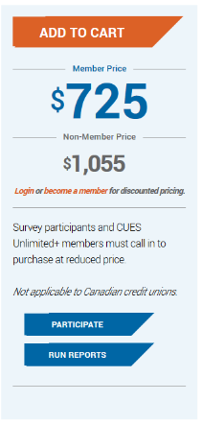

Click the blue PARTICIPATE ribbon in the shaded area on the left. Log in. The page will refresh. Click PARTICIPATE again.

What happens if I forget my password?
If you forget your password you can enter your email or username at the “forgot your password” link when logging in or contact Survey Support at 866.508.0744 or surveysupport@cues.org

Can I share my user name and password with others at my credit union that may need access to the
online reports?
Please do not share your login information with anyone. If someone else at your credit union requires
access, please contact Survey Support at 866.508.0744 or surveysupport@cues.org.

Why does CUES require a CUES login to participate in the survey?
CUES understands the importance of keeping compensation data secure and confidential. Our login process requires each participant to be granted access to participate, so your data remains confidential.

Do I have to submit data for every position?
No. Please only submit data for positions that relate to those in your own organization. Look for a 75% match between the CUES position description and your credit union’s position description. Do not match position titles alone as those vary greatly from credit union to credit union.

Does CUES want data that is current as of right now, or data from our last salary review?
Please provide us with data that is current as of January 1 of the current year.

Do I have to do it all at once?
No. At any point in filling out a position’s information, you may choose the “save and exit” option to save the data you have entered. Be sure to return and choose submit prior to March 31 so your data will be included in the survey.

What if I need to correct information after I have submitted my completed survey?
Simply enter the information again on the survey page and be sure to click the "Submit" button. You may submit corrections through March 31.

The Survey link isn’t active. It is grayed out. Why?
You must first complete the Credit Union Profile. Once you’ve completed and hit submit on the Credit Union Profile, the survey link will be active.
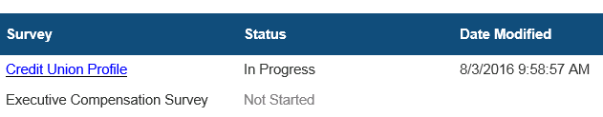

How can I tell which positions I’ve submitted already?
The status column next to each position will let you know:
- Blank – this position has not been started or saved, and is not submitted
- Complete – this position is done and submitted. You may still make changes prior to March 31
- In progress – this position has some data entered but is not submitted and will not be included in survey reports. To be sure to include these data, you must go into the position and click “submit.”
- Outdated – this position has data from the previous year. Update the data if you wish to include it in this year’s survey report.
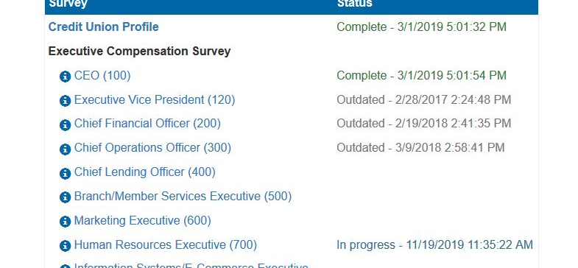

I’ve participated. Now what happens?
CUES will collect data through March 31. At that time, all data will be reviewed and cleaned. The survey results will be released in July via CUES dynamic online survey reporting tool and summary data will be released in the annual CUES Executive Compensation Summary Report; both of these resources are available to CUES Unlimited+ Members and to purchasers of the survey reports. Last year’s data will still be available for reports during the review period.

I’m not sure my credit union has purchased the survey results. How do I find out?
Contact CUES to find out if your credit union currently has a subscription to the CUES Executive Compensation Survey and Reports. You need just one subscription for your credit union; each individual does not need a subscription. Contact CUES Survey Support at 866.508.0744 or surveysupport@cues.org.

